THE ART OF LEARNING/LEARNER ENGAGEMENT THROUGH AUGMENTED REALITY

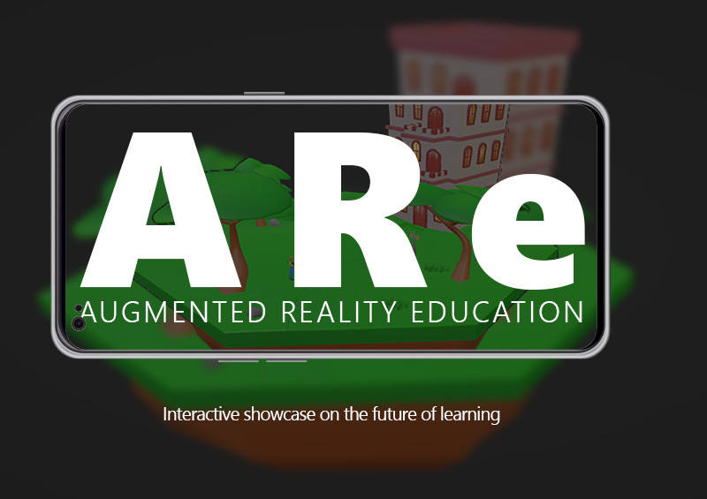

by
Tughu Aiyewa

INTRODUCTION

Learning entails transformative discoveries that reshape one's worldview and reveal the potential impacts of acquired knowledge. However, a lack of excitement in learning experiences may arise when individuals are unfamiliar with effective learning approaches, indicating a mismatch between the learning process and an individual's interests or unique needs. Growing up, certain subjects were much easier than others for me. Subjects like geography, art, and biology – or any subjects where images were available, made learning much more intriguing. Yet I struggled with abstract subjects like mathematics where numbers existed on a plain white background, covered with blue grid lines because I couldn't understand the significance of the numbers at the time. Interestingly, I began to struggle with subjects I did enjoy when faced with long blocks of text without any visuals. I wasn't the only one caught in this predicament, other young learners couldn't grasp the relevance of numbers in real life. This made me wonder if everything could exist as art if it were illustrated.

Education has evolved beyond traditional methods of textbooks and blackboards. The advent of the internet and search engines has made it effortless to access information without any second thoughts. Virtual and Augmented reality are increasingly becoming important technologies in the education sector as they offer an immersive experience. The way we learn is influenced by the innovations that exist. These innovations have a significant impact on shaping our learning experiences. (Mulford B, 2008).

Technology can help bridge the learning gap, especially for visual learners like me. I initiated my exploration of the visualization of abstract concepts in 3D, and their easy display through mobile devices accessible anytime and anywhere. This led to the birth of my project ‘ARe – Augmented Reality Education’.

My project aims to create an enjoyable learning experience for students by using 3D visuals to break down complex abstract concepts. This will help to keep them engaged and maintain their interest throughout the learning process. I faced a question that defined my work: How can learners engage with abstract subjects through AR, visual designs, and interaction?

ARe is a mobile application that uses augmented reality technology to provide an interactive learning experience The app generates 3D content on a mobile device which can be explored and interacted with through screen-touch interactions. Mathematics was chosen as the subject to be visualised, and Biology was also included to explore additional features to increase user engagement and learning. The application was developed using Unity and Vuforia engines specifically for Android mobile devices.

I utilized the Agile methodology variation to approach my project as a software development task and followed the Software Development Life Cycle process model to ensure proper planning and implementation. Testing was crucial for the entire development timespan; thus, I implemented Test-driven development.

During the project, I quickly realized the extensive work involved in developing visuals for abstract subjects. As a result, I chose to focus on visuals and interactions for learner attraction and engagement. In this critique, I will discuss my approach to achieving this. I will also address the project's limitations in terms of specific design choices and how they impacted the project’s outcome.

LITERATURE REVIEW

Augmented Reality has a history that spans several years, during which it has undergone improvement through technological advancement. Early implementations of AR have been in projects revolving around scientific and military use (Geroimenko, 2012, p. 445). Augmented reality can be defined broadly as the seamless integration of digital content with the physical (Yuen et al. 2011). Geroimenko (2012, p. 447) alter our AR perspective with new insights into its current and future use. According to his research, AR adds computer-generated objects to the real world, providing sensory experiences beyond sight, such as smell, touch, and taste, in real-time. Research by Van Krevelen and Poelman (2010) argues that to fully comprehend the concept of AR, it is imperative to acknowledge that its definition goes beyond the visual sense and encompasses the ability of AR to engage other senses as mentioned earlier. It is possible to imagine the endless potential of AR technology across multiple industries. One major application of AR technology is in marketing. Marketing campaigns have evolved to provide an immersive experience, allowing customers to interact with digital models of real-world products such as cars and toys (Yuen et al. 2011, p. 124). Users can view products from different angles and sizes using hand gestures based on their interaction preferences. Carmigniani et al. (2011, p. 342) provides more examples of AR applications in medical science-based fields where Collaborative AR interfaces could be integrated with medical practices for surgeries and medical diagnosis.

AR technology, is still considered a developing medium in its initial stages, according to Yuen et al. (2011). Developing functional AR applications, as emphasized by Luckin and Fraser (2011), necessitates a diverse skill set encompassing both artistic and technical abilities. Saidin, Halim and Yahaya (2015, p. 1) agrees, noting that the limited research on AR in education restricts our understanding of its feasibility and accessibility in the educational field. Nonetheless, Saidin, Halim and Yahaya (2015) highlights numerous benefits of AR in enhancing student learning, transforming passive learning into an interactively engaging experience.

AR's advantage lies in its ability to incorporate digital content from various sources, such as 3D assets, infographics, and audiovisual materials. An evaluation of a BBC-developed AR learning application demonstrated that 3D models and characters can generate excitement among young learners. The BBC AR experience, based on a storybook model, allowed users to trigger 3D content by holding up a book or printed card to a webcam-enabled device. Results indicated active engagement, with 98% of children interacting with characters and 93% enjoying both characters and written content. Overall, the positive response illustrates one of the educational benefits that AR can provide.

AR can positively impact learners' performance, particularly in comprehending challenging, abstract concepts that often discourage students from science-based subjects (Saidin, Halim and Yahaya, 2015, p. 2-3). The mode of presentation significantly influences interest and engagement in learning, as noted by Saidin, Halim and Yahaya (2015), emphasizing the boredom and disengagement associated with traditional chalk-and-board lecturing. Supplementary research from Bacca Acosta et al. (2014) underscores AR's utility in enhancing motivation for learning. When used as a complementary source alongside physical content, AR visualizations for abstract concepts improve student comprehension, reducing reliance on imagination alone. Their study reports a 53.3% improvement in learning performance, accompanied by a 28.1% increase in motivation and a 15.6% rise in engagement through AR applications.

Notwithstanding, the integration of AR technology in educational settings is constrained by certain limitations. AR systems rely on camera and marker recognition for model placement, leading to extended wait times when markers are inaccurately identified, causing user uncertainty about the application's effectiveness. This circumstance, as evidenced in Bacca Acosta et al. (2014), frequently results in user frustration. Furthermore, Diegmann et al. (2015), notes the indeterminate value of AR applications arises from variances in their assessments of the benefits of learning outcomes.

AR APPLICATION REVIEW

Upon reviewing the works of literature, I examined the inherent potential of AR for educational purposes, considering limitations imposed by current technological resources and development constraints.

To advance my research, I systematically explored extant AR software designed explicitly for educational purposes. Employing the Google search engine, I utilized keywords to refine the search results exclusively to AR software tailored for educational contexts. During my search, I discovered an AR tool created by Burgess Jeffries for visualizing pre-calculus problems in mathematics (GeoGebra, 2020). Utilizing a graph model with points across axes (x, y, and z), he demonstrated the application's capability to represent mathematical concepts of angles during a plane's take-off (Figure 1).

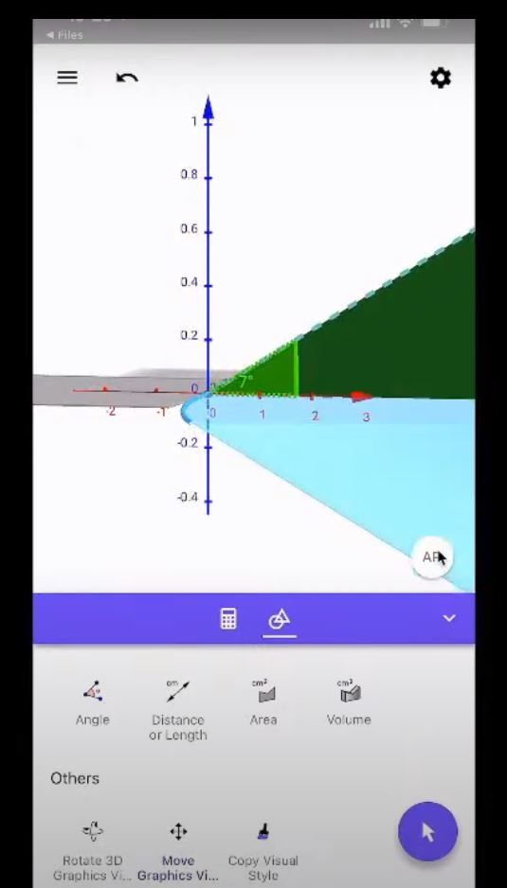
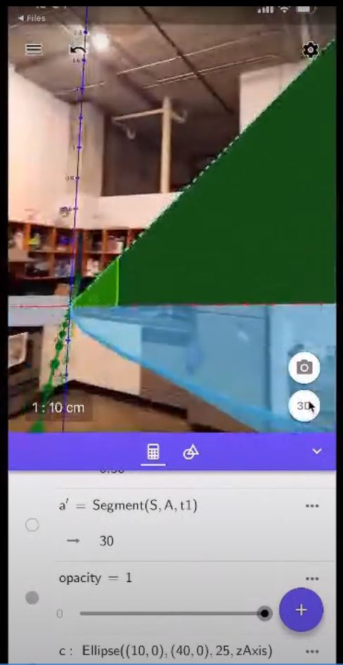

Figure 1: GeoGebra AR math demonstration (GeoGebra, 2020, 27:00; 32:04)

Burgess manually crafted these models using the Geogebra online mathematical tool. Users accessed the AR experience through their iOS-enabled devices from the website. Motivated by his innovative approach and considering previous research, I aimed to develop a prototype incorporating key aspects of his work, focusing on visualizing abstract mathematical concepts, and enhancing user interaction for improved learning experiences (Yuen et al., 2011 ; and Luckin and Fraser, 2011).

MAIN BODY

Leveraging existing technology and my knowledge, I aimed to design a finger gestures interaction on a mobile screen. Consequently, I chose to incorporate the following gestures for interaction.
- Pinch scale – using the Thumb and Index finger to scale the virtual content on the screen
- Rotate – sliding the Index finger on the screen, either left to right to rotate the content in either direction
- Translate – move the content through three-dimensional space by placing the index finger on the virtual content and dragging it across the screen
- Display 1 – hide/unhide portions of the content or display hidden contents by double-tapping on the screen
- Display 2 – Show annotations and additional information through a touch-hold of the screen
Applying a user-centric design principle, as detailed in Dunser et al. (2007), I aimed to reduce the inherent learning curve associated with navigating ARe. This was achieved by incorporating intuitive gesture interactions commonly found in modern touchscreen mobile devices.

ARe: PLANNING AND DESIGN

PLANNING

During planning and design, I created a storyboard to visually depict the prototype's precise functionality, facilitating necessary adjustments. Tailored for self-learning, the project is illustrated with a single learner in his own space. To efficiently manage development, I established a timeline with weekly goals, evaluating the prototype's functionality through test builds at the end of each week. Employing an agile design method, I integrated the testing of new visuals or features after each weekly sprint, aligning with a software development approach (Mishra and Dubey, 2013). Additionally, I required a testing model that could provide feedback for new iterations and continued testing during production. This goal was achieved via Test-driven development (IBM, 2023).

DESIGN

Centering my design around user engagement and interest, I opted to explore visually appealing elements for my digital content. Considering the mobile development context, I sought a method to present my models with optimal visual quality while preserving device performance. To reduce the polycount, I opted for low-poly models and employed gradient texturing for the final renders (Figure 3). Downloaded assets with high resolution were optimized using decimation to maintain functional polycounts.



Figure 2: Gradient texture, used in texturing models in Blender and Unity

For the learning experience, I chose trigonometry as my focus because of its challenging nature in mathematics and the visual aids commonly used in trigonometric problems. After receiving feedback from informal peer reviews, I decided to proceed with the circulation of blood in the heart for the second topic. The purpose of choosing these subjects was to demonstrate abstract concepts visually while testing user engagement and exploration.

An ARe marker was developed to replace the traditional 2D images on paddles, as demonstrated in Luckin and Fraser (2011). The marker takes the form of a textbook page that incorporates educational material along with distinctive patterned images

ARe: DEVELOPMENT, CHALLENGES AND SOLUTIONS

I researched tools for AR development, prioritizing control over features. Unity was chosen as my preferred platform, followed by an exploration of AR Foundation and Vuforia AR SDK. Evaluating both, I found AR Foundation setup initially smoother but faced challenges with image tracking. Attempts to combine Vuforia and AR Foundation resulted in errors and lag. To address this, I discovered Lean Touch, a free Unity plugin, and refined the system using Vuforia for its straightforward image tracking.

While developing, I realized the "Lean touch Rotate Axis" component required a two-finger interaction. I aimed to create a user-friendly prototype that used the index finger for interaction, except for scaling. I combined custom-written C# scripts with the Leantouch Scale component, enabling me to rotate and scale. However, implementing the lean touch translate component caused a script conflict, causing the 3D model moving and rotating simultaneously. To address this, I made the object's movement activate only when the user touched and moved it, while also blocking any rotation during translation using a constraint in the translation C# script.

Adhering to my timeline, I initiated work with cubes and test markers, focusing on developing interactions and on-screen features. This strategy aimed to establish fundamental interactions and address challenges concurrently with advancing the 3D production pipeline, allowing for the creation of 3D models for both subjects. In the final stages, I replaced the cubes with finalized 3D assets (Figure 3).

In choosing visualizations, I pursued an art style balancing playfulness and relevance, using vibrant colours for user engagement. Employing a gradient texture approach facilitated smooth transitions between colour gradients without inflating file size (Figure 2).

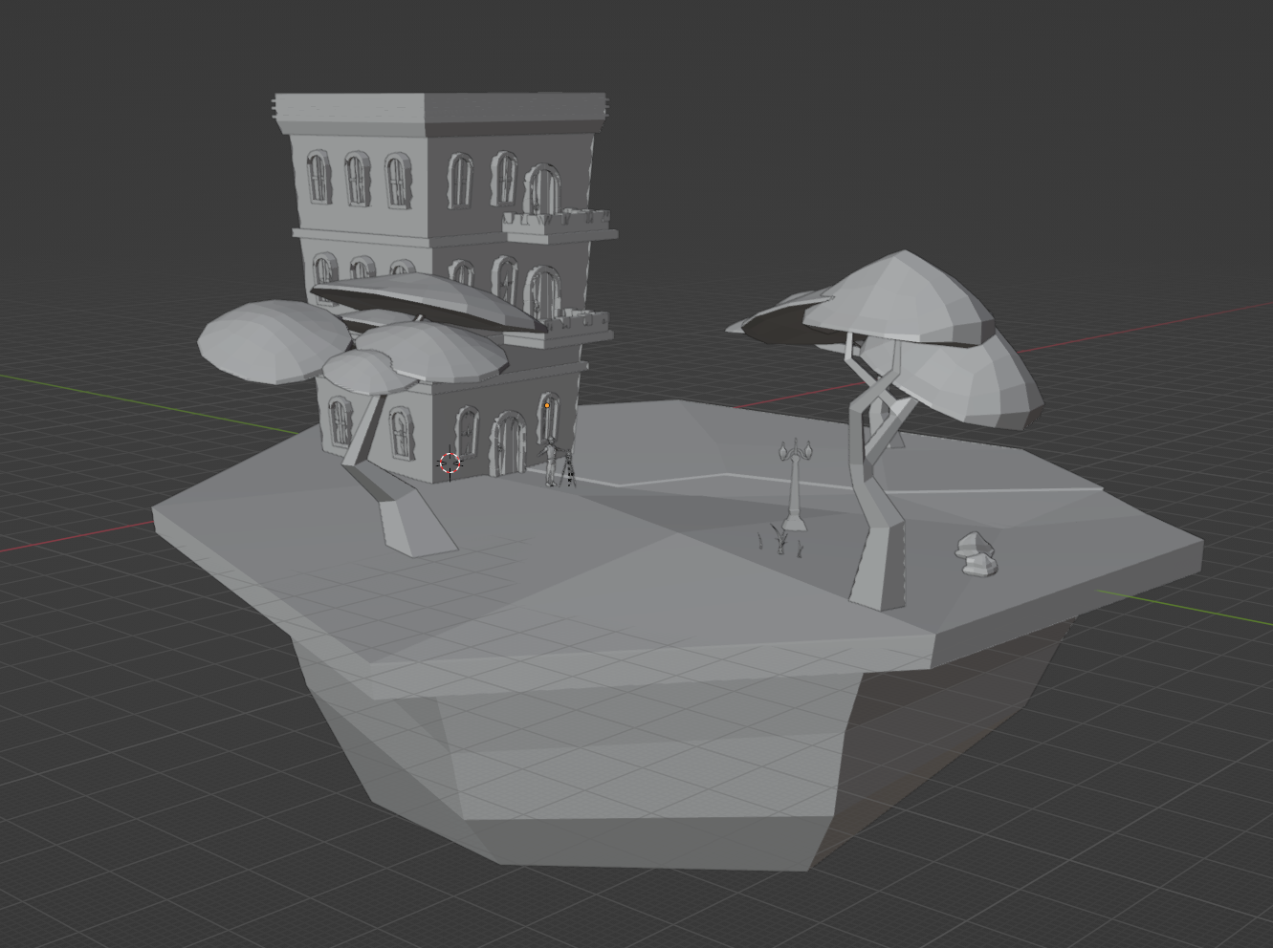

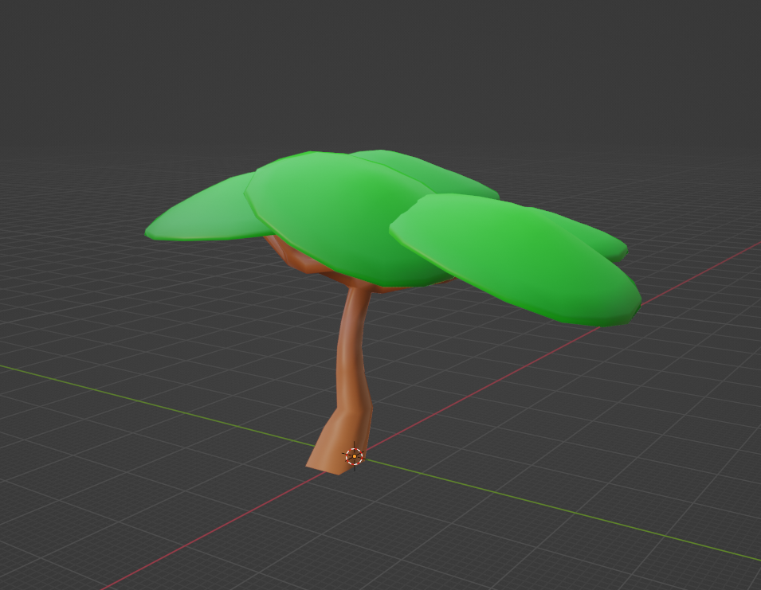
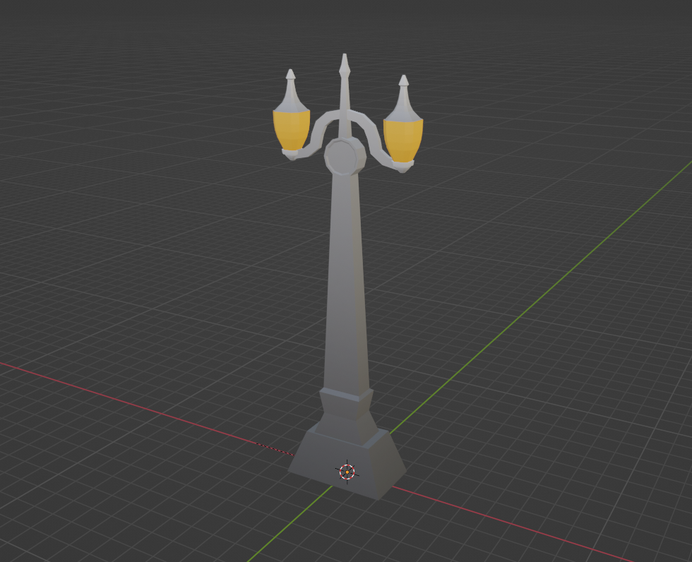

Figure 3: Lowpoly models for mathematics experience. Top: Complete Diorama representation of trigonometry problem; Right: Tree model; Left: Street lamp, both fully textured.

To augment the learning component, an information board was incorporated, housing trigonometry details, clues, and formulas accessible through hand placement. Additionally, a triangular image could be unveiled through a double-tap gesture. In Biology, animated arrows illustrated blood flow between ventricles, providing a realistic depiction compared to conventional 2D images.

For my presentation, I utilized custom markers generated from brosvision.com, and integrated them with subject-specific images—a modified human heart for biology and a 2D representation of a trigonometry problem for mathematics (Figure 4). This, combined with the final textbook design, resulted in a distinctive and purposeful presentation using the Vuforia image tracking system (Figure 5).




Figure 4: Marker for mathematics content. Left: Original marker generated on brovision; Right: Edited marker combined with mathematics element.

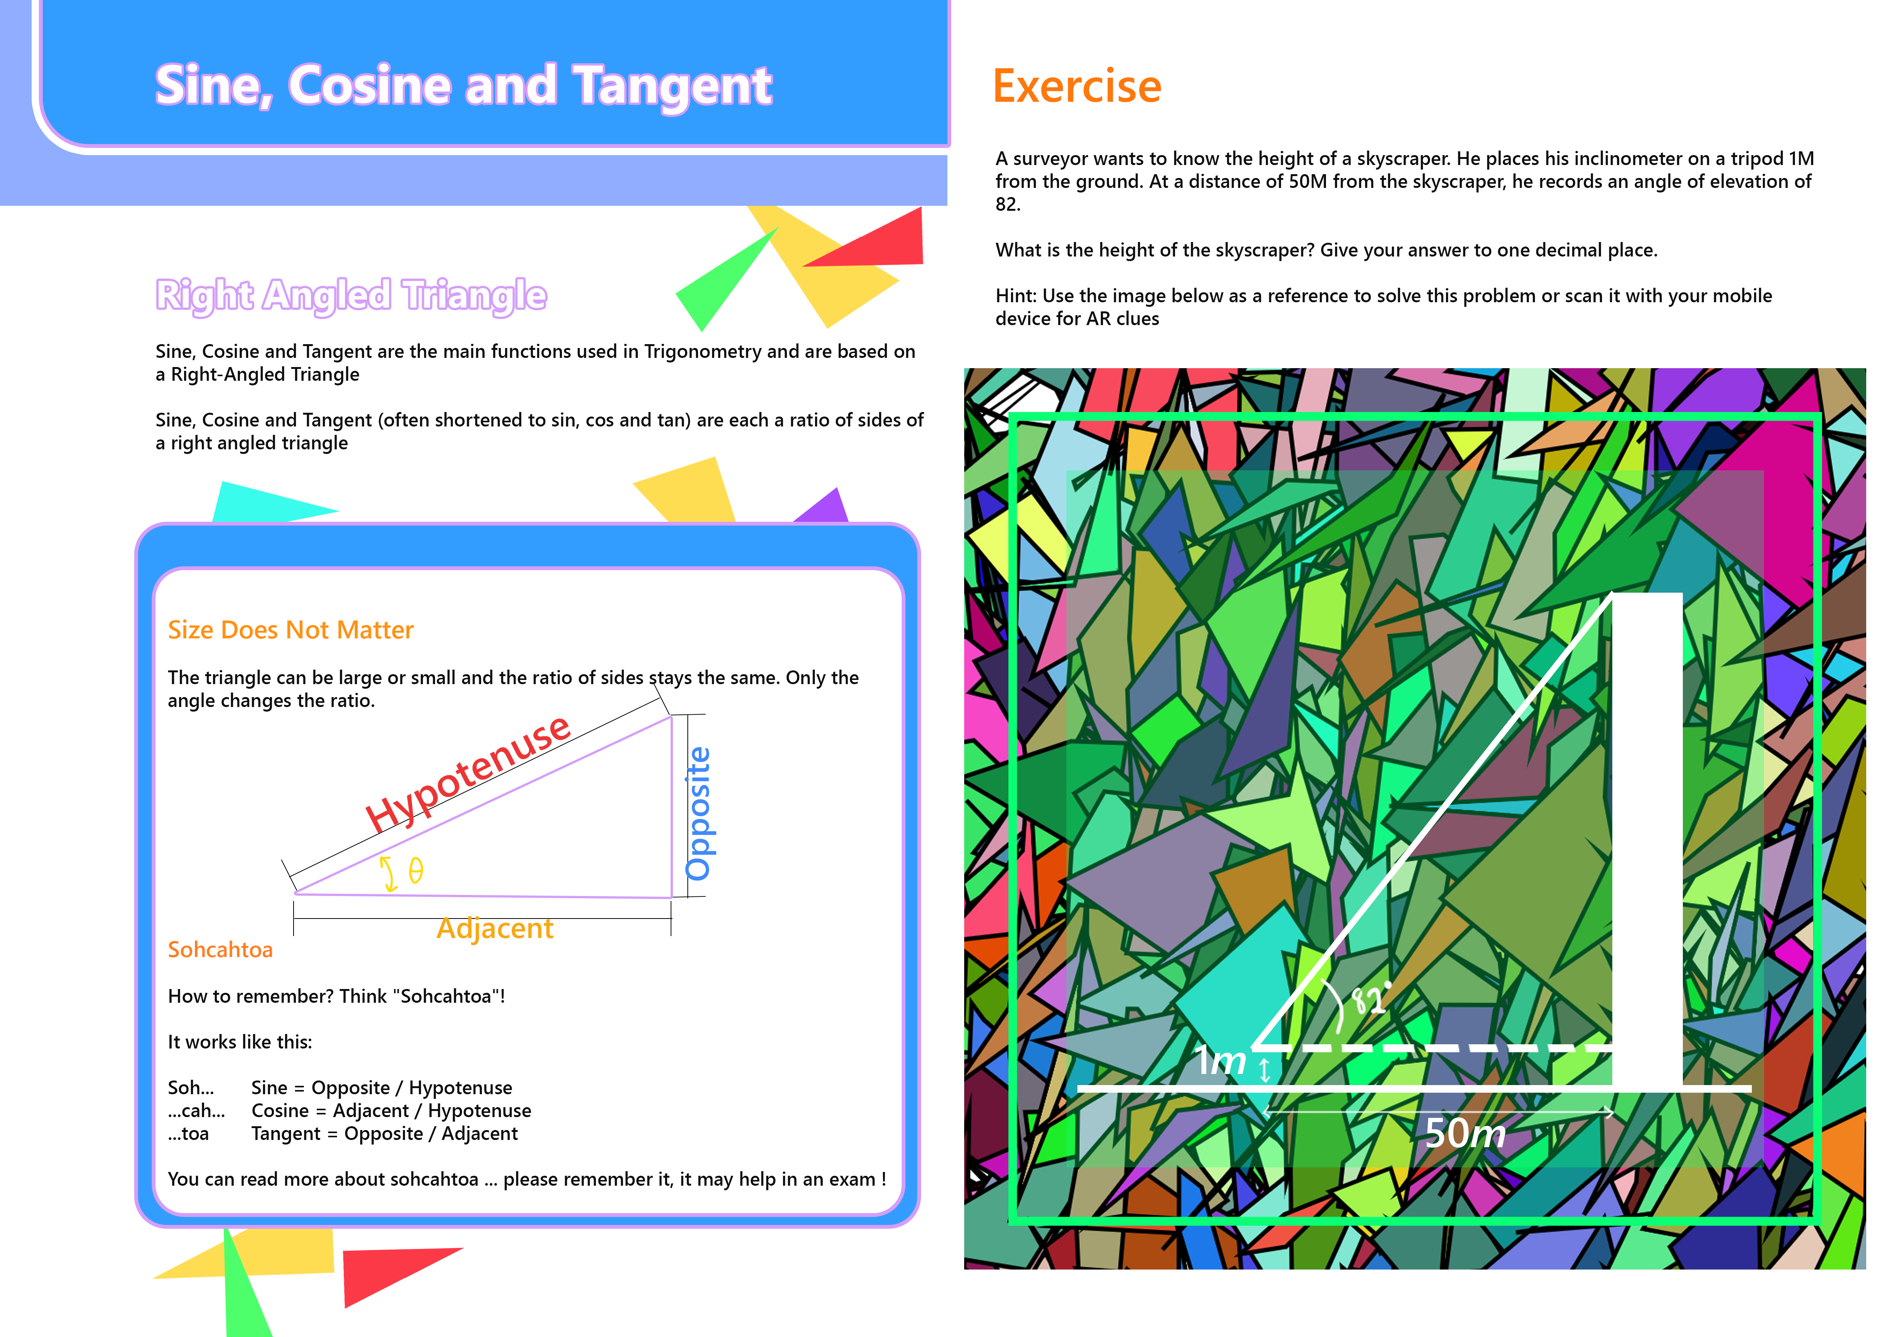

Figure 5: Marker for mathematics content in textbook design

ARe: THE TEST

As a project component, a functional prototype was publicly showcased for two days at the UWE City Campus, Bush House. To start, I had to prepare the setting. I arranged my display area to represent a standard study space. My objective was to create a mindset of willingness to learn among users. Moreover, the scene was set to showcase the potential of ARe for self-learning outside of the classroom setting (Figure 6).

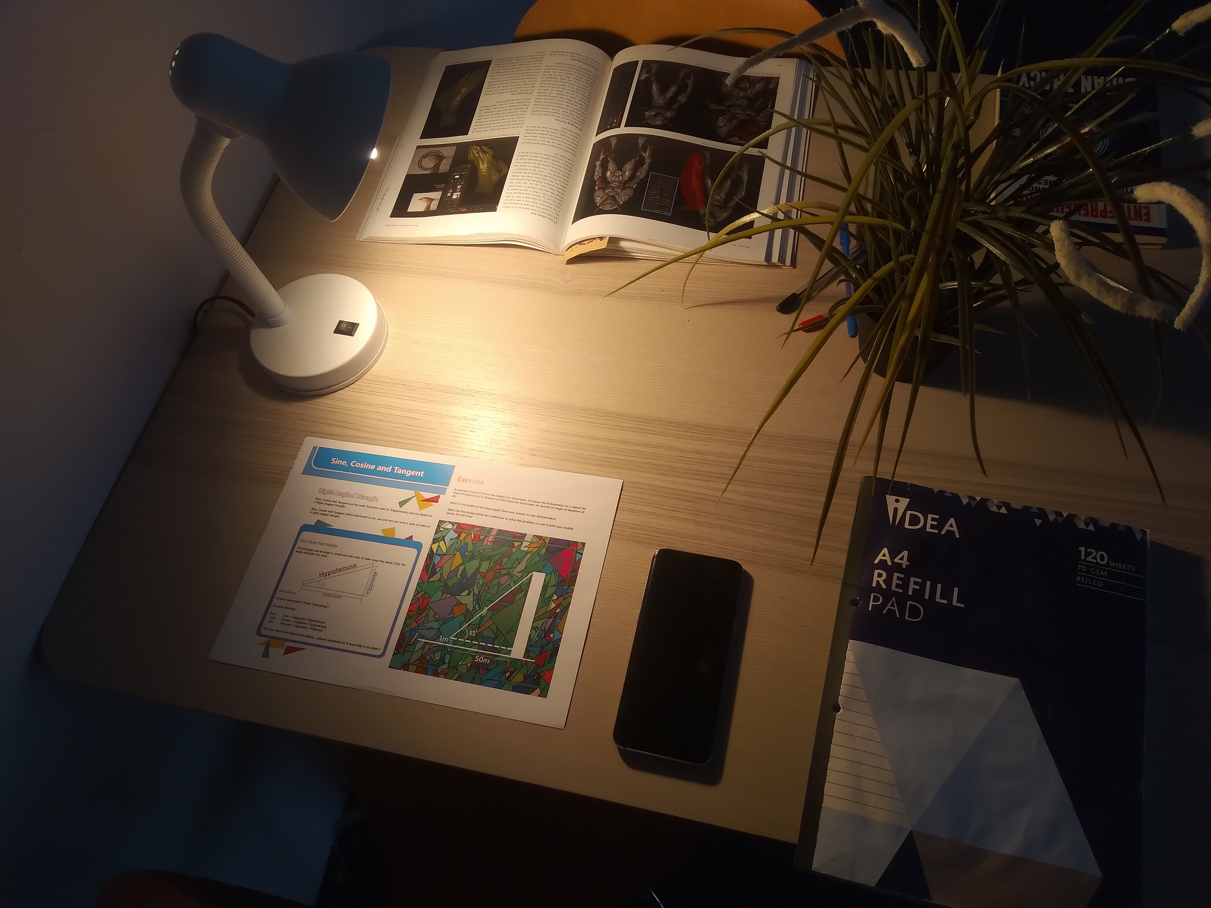
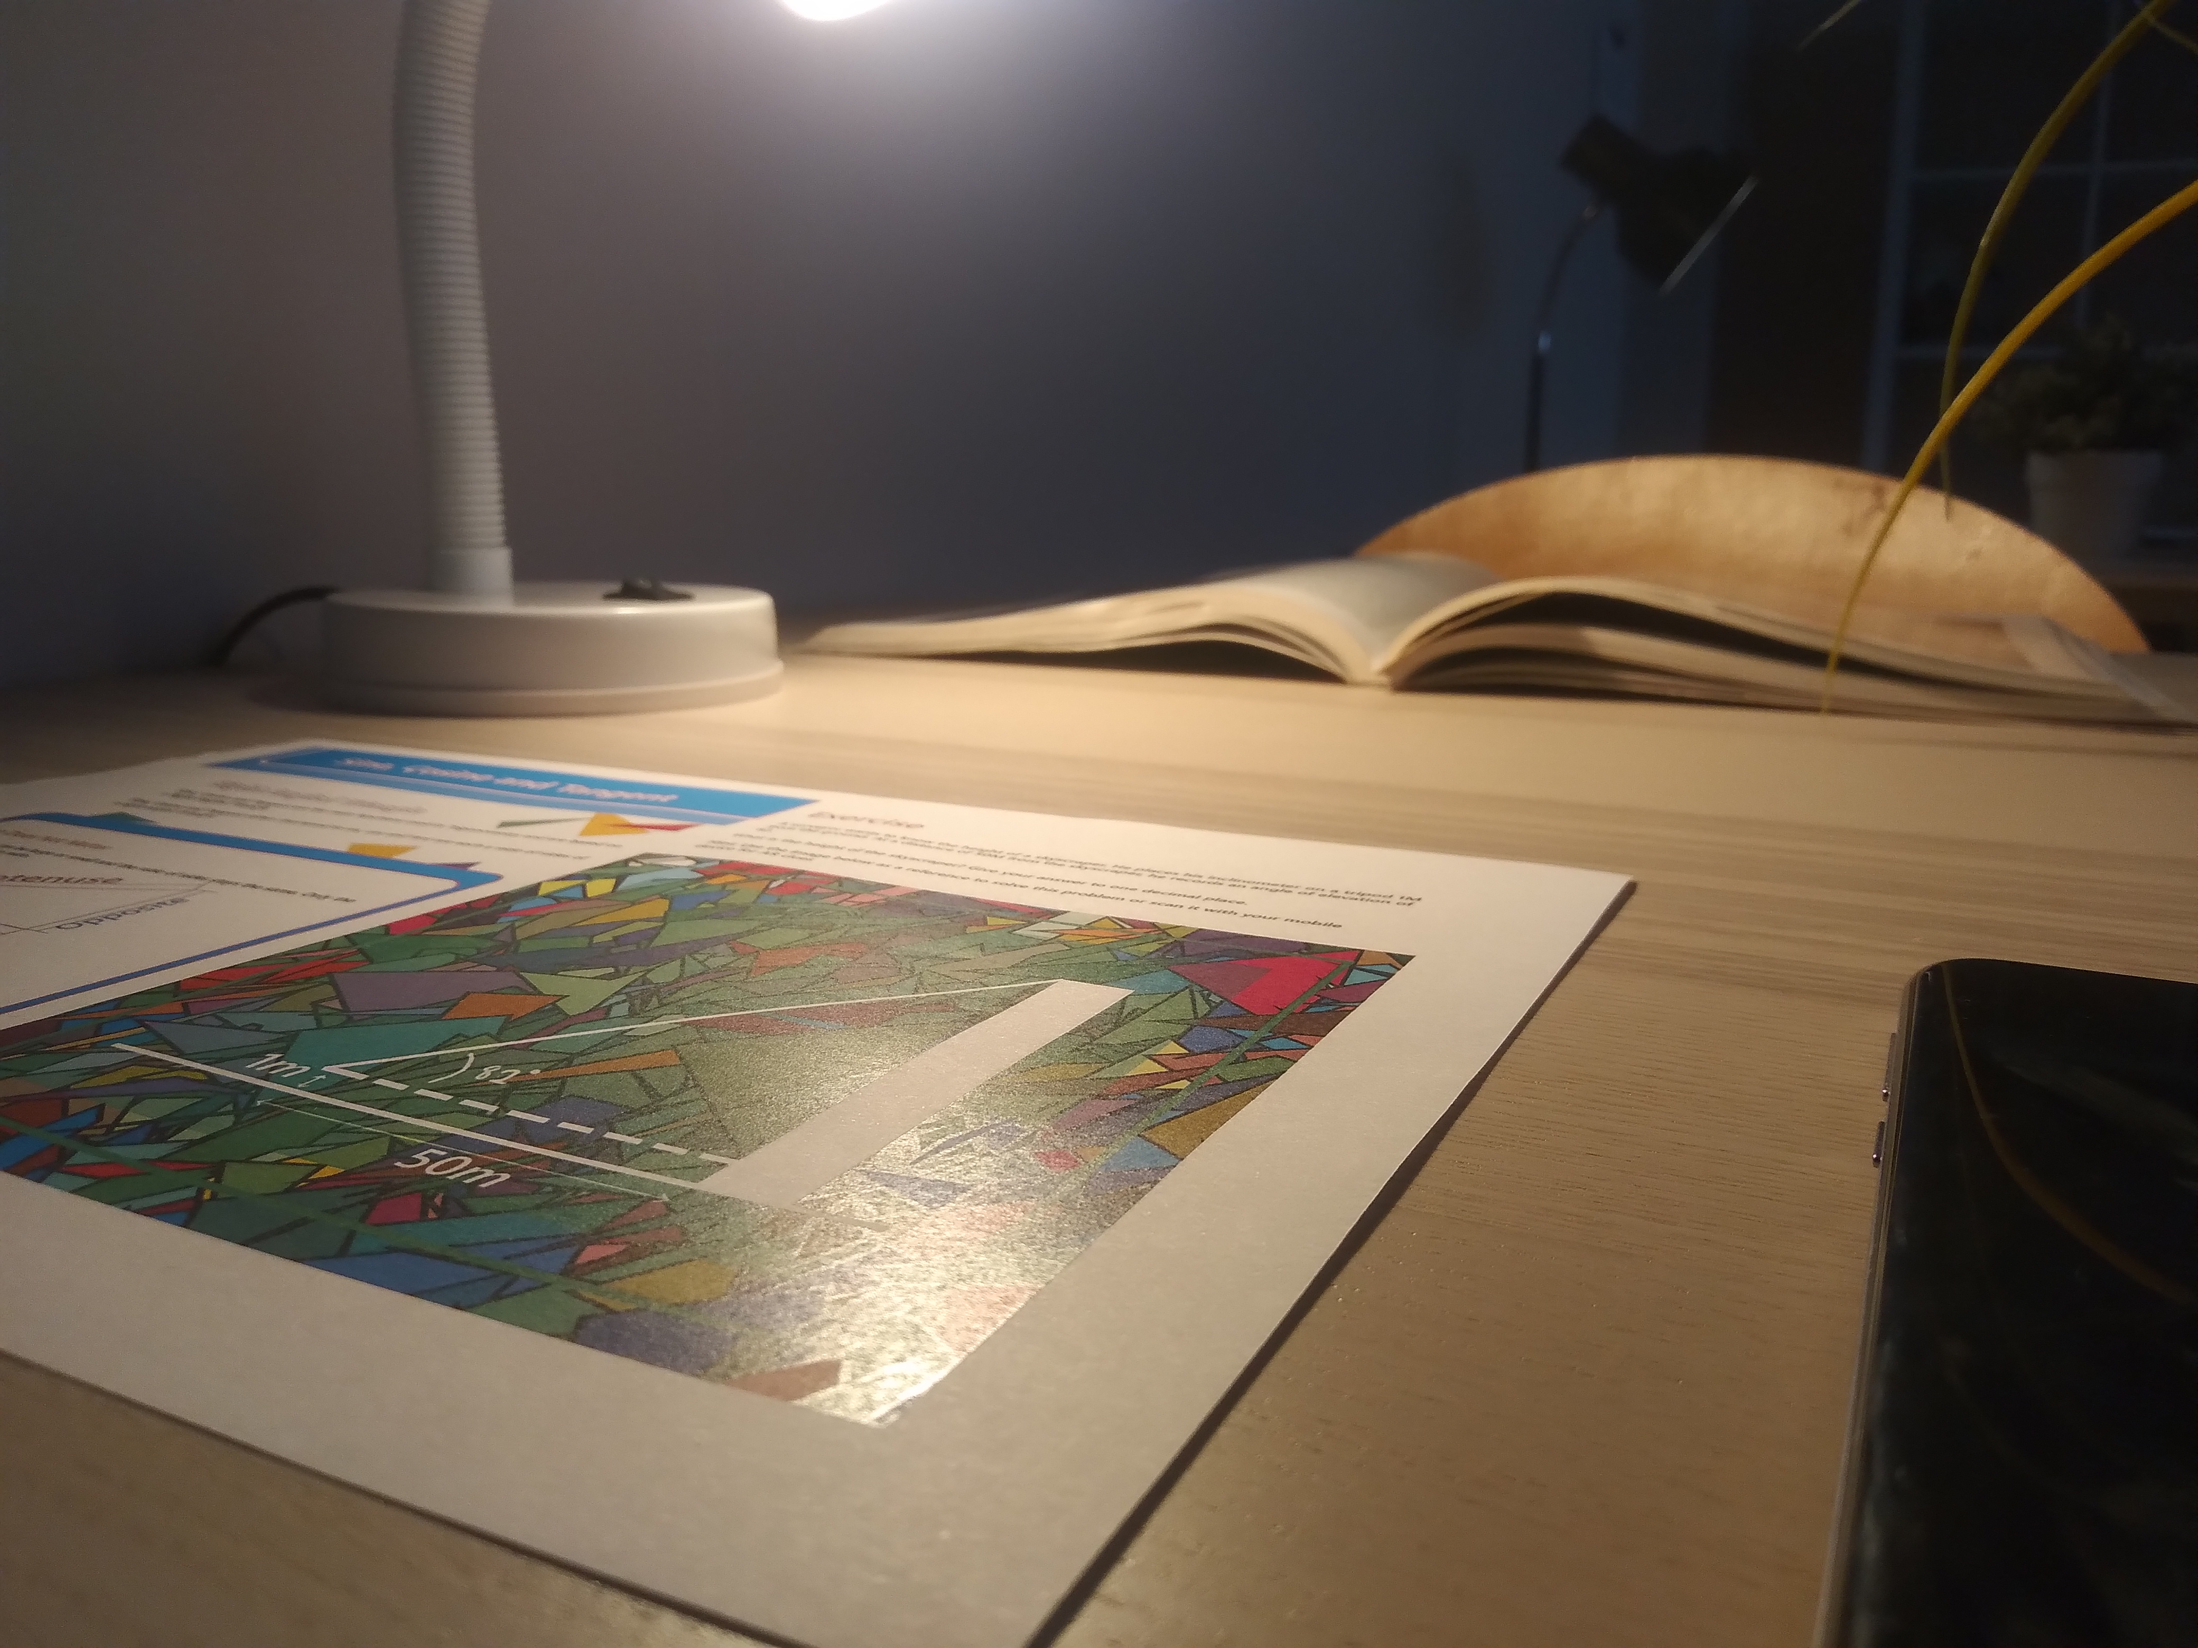

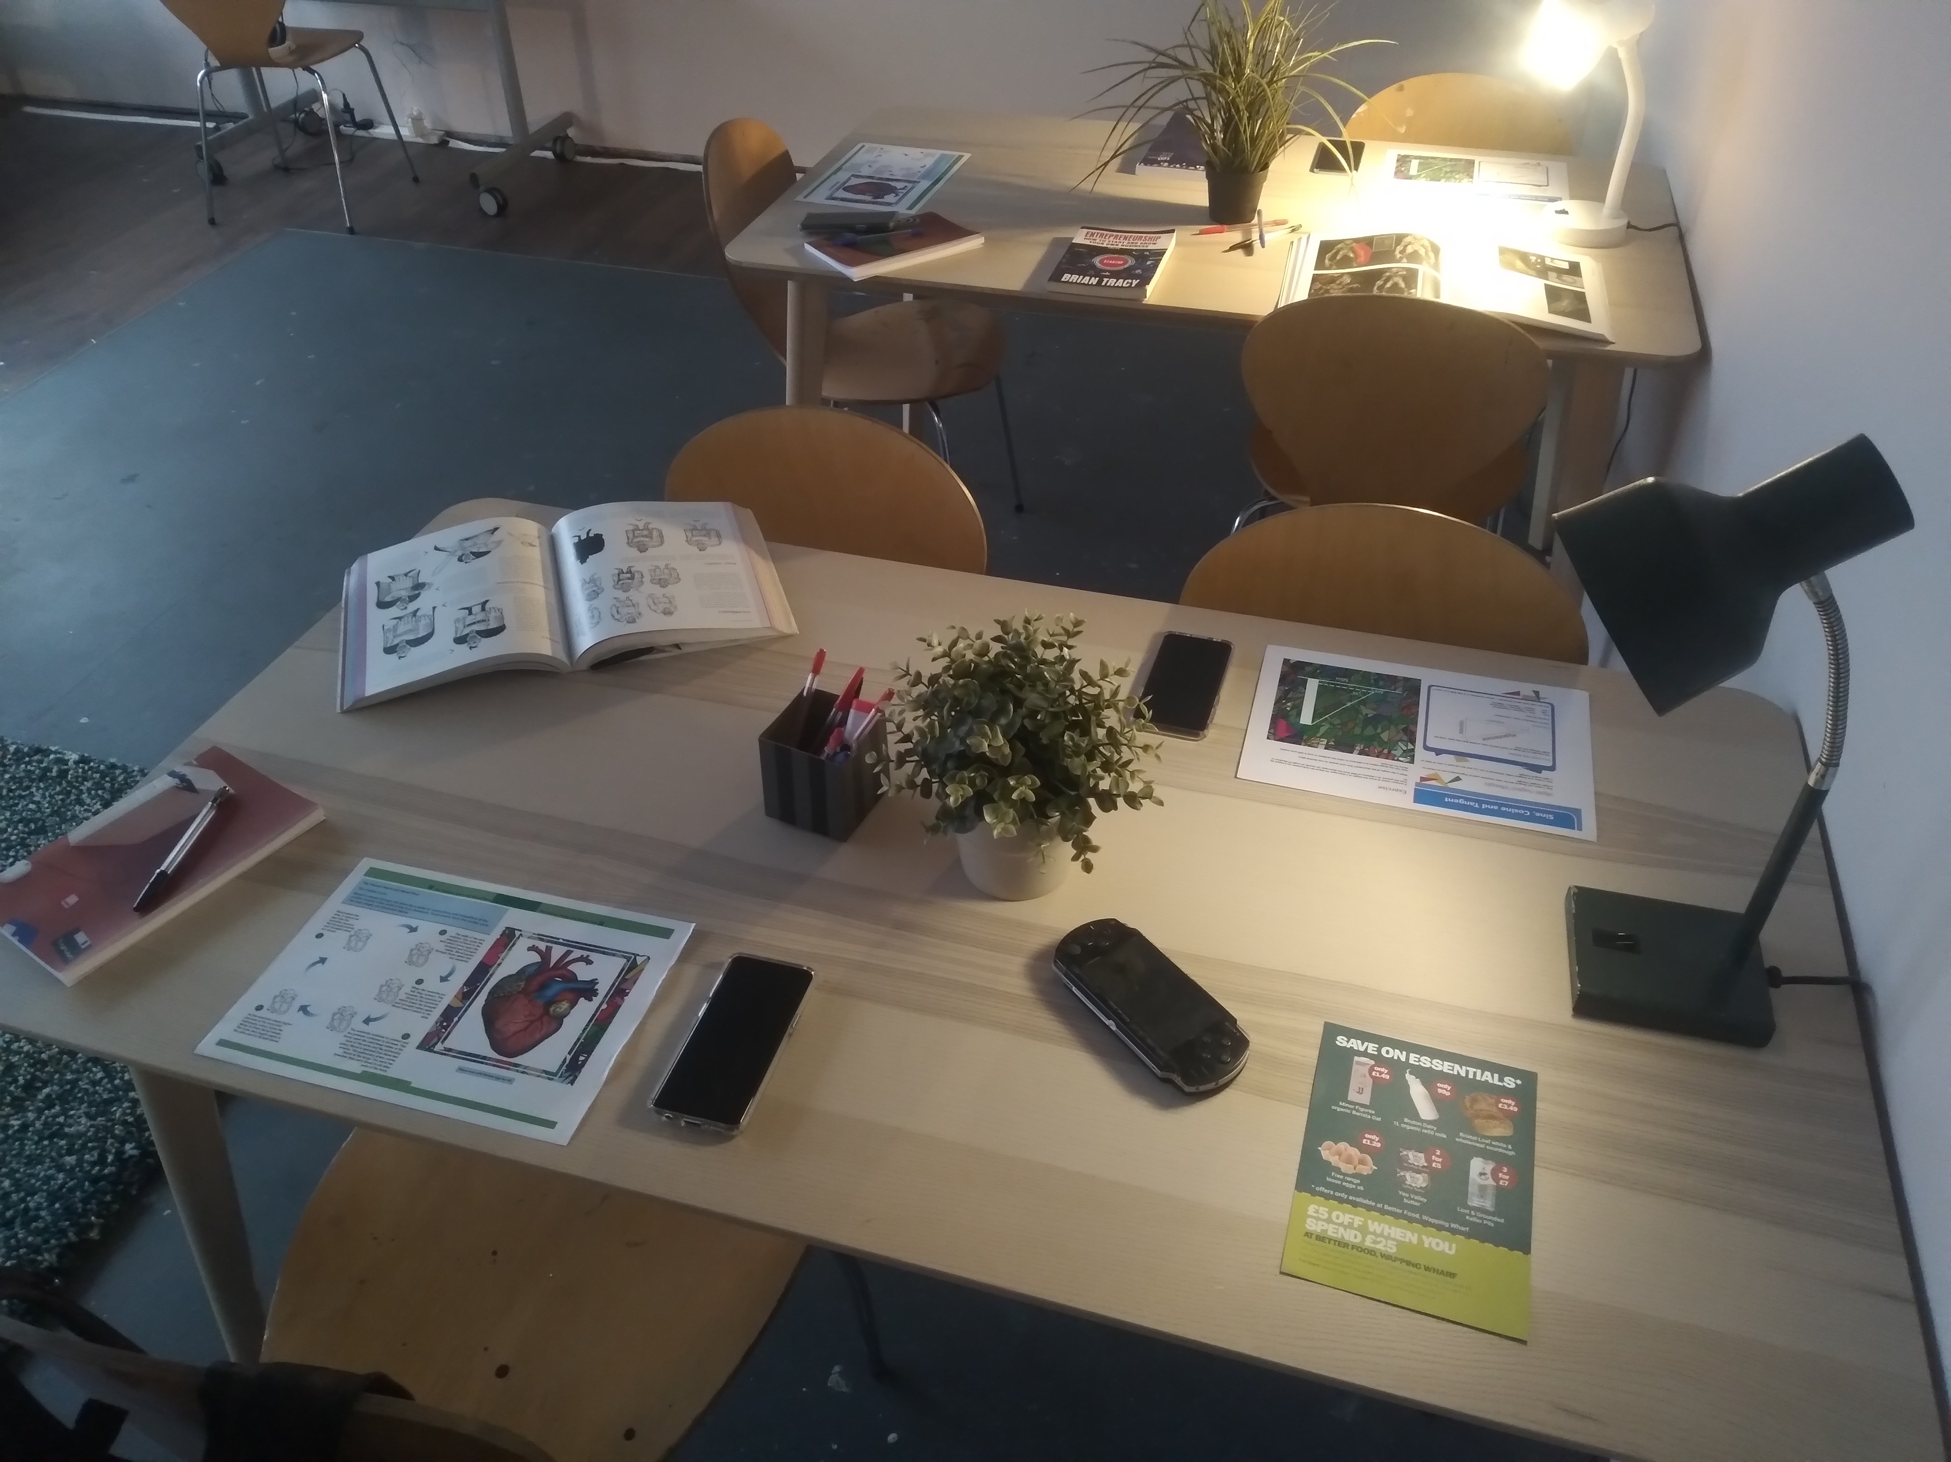
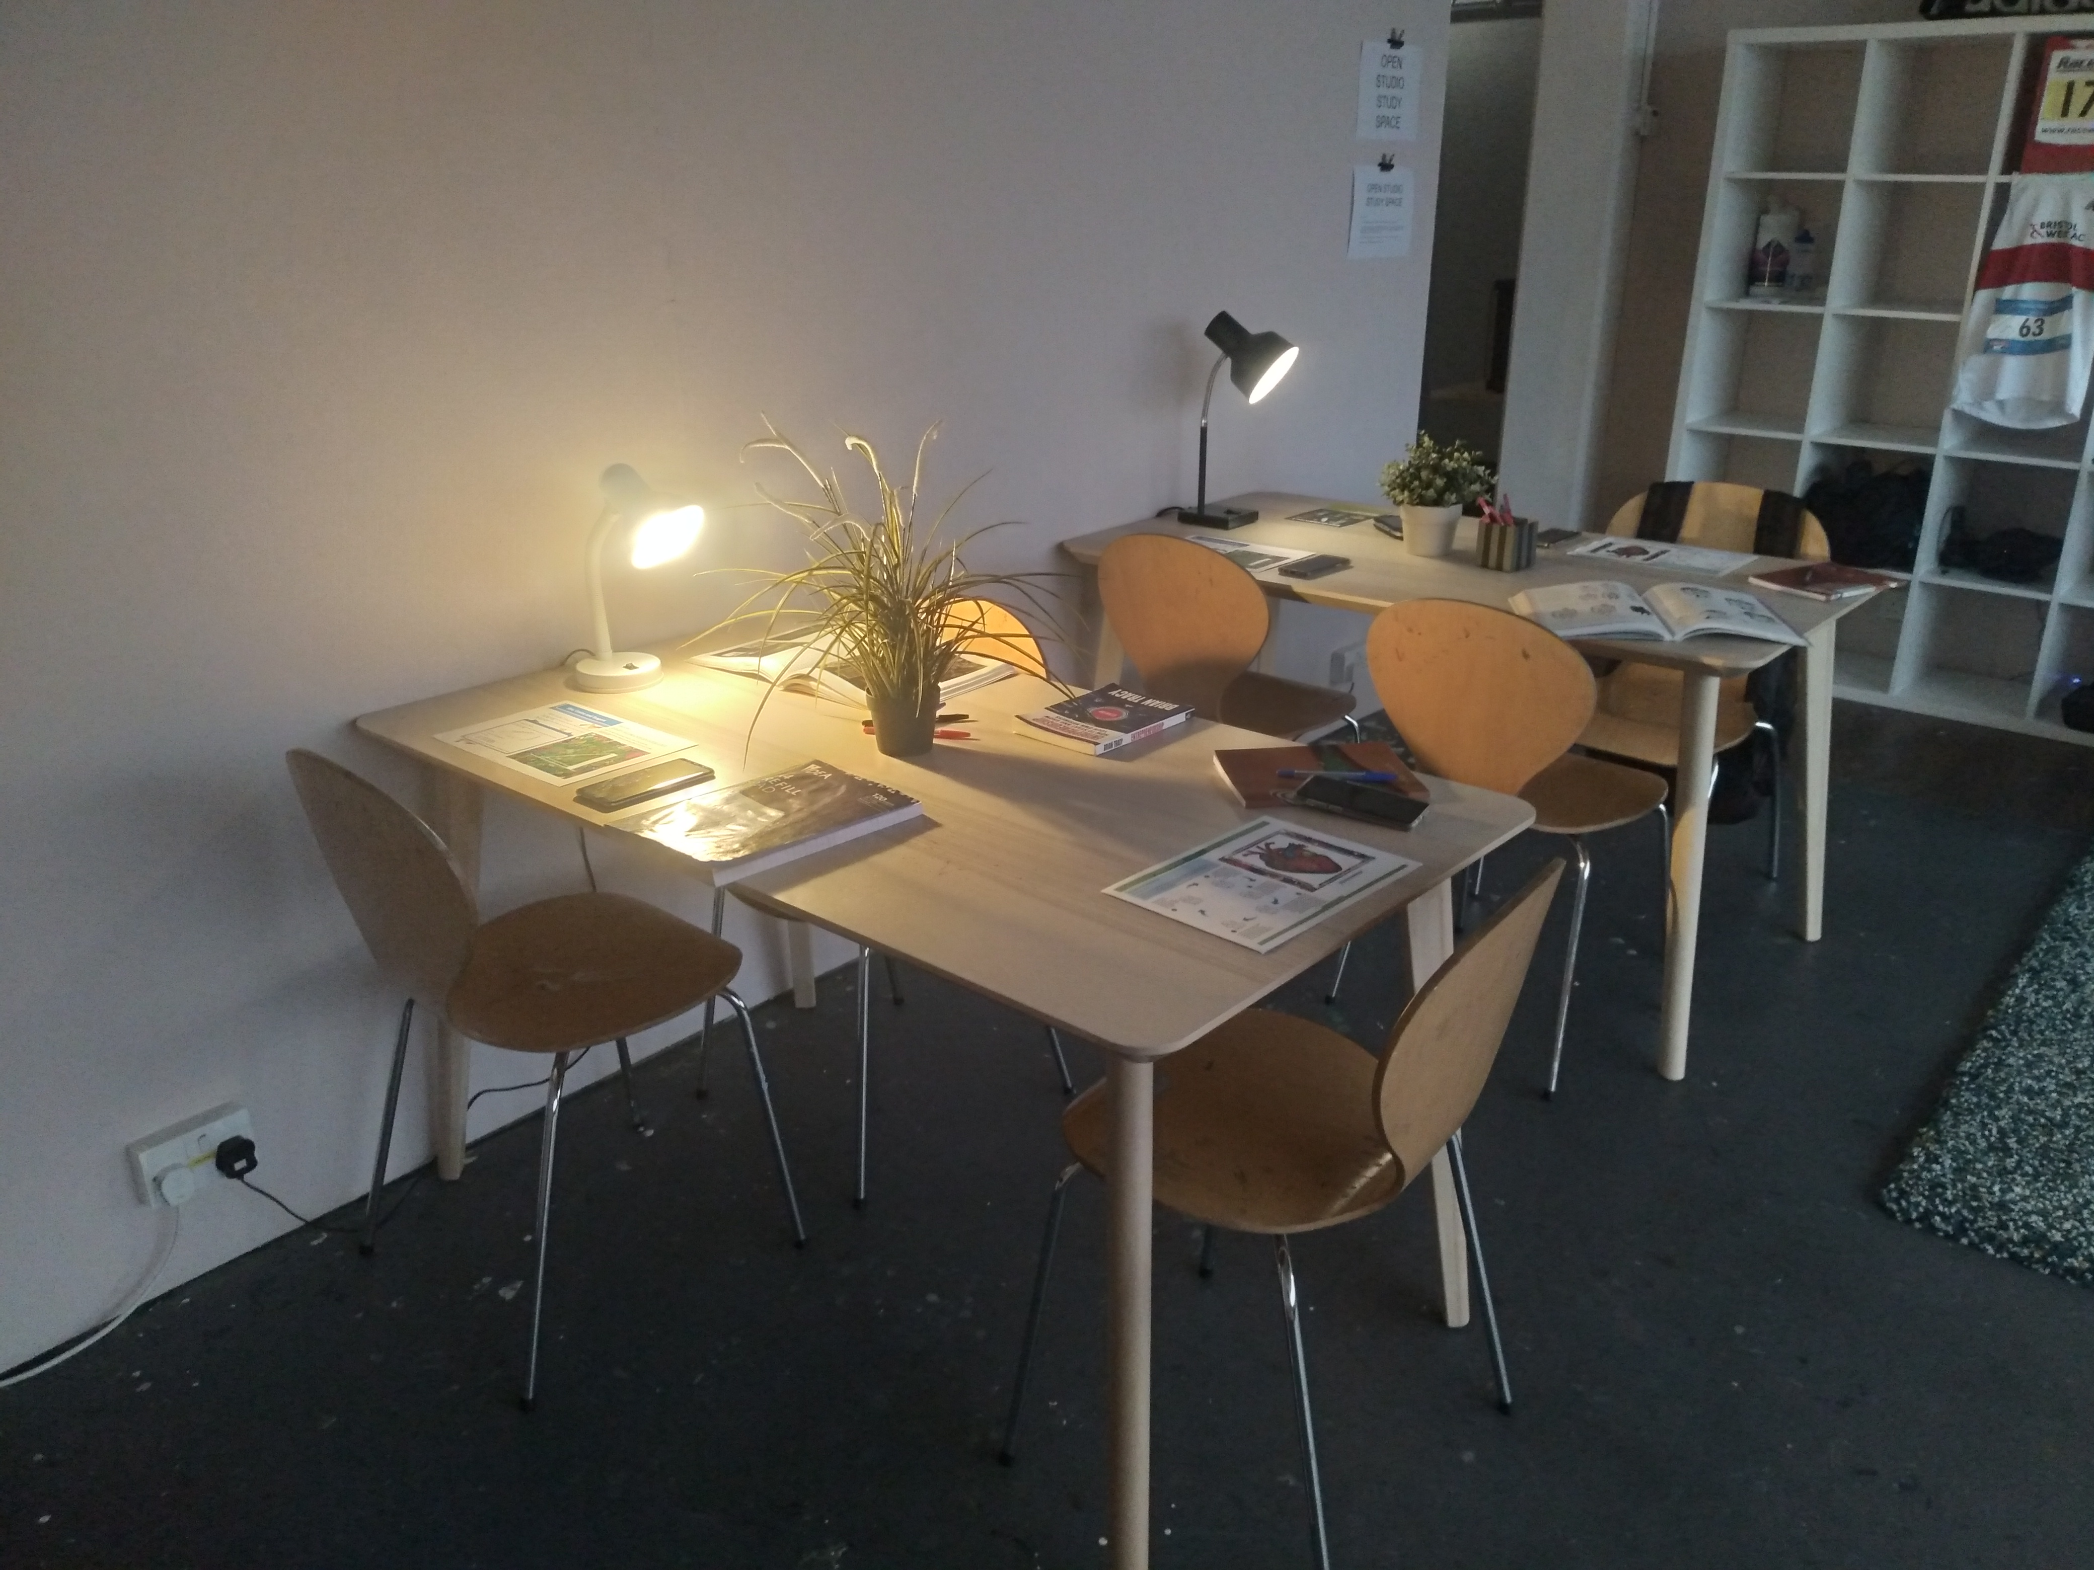

Figure 6: ARe Showcase space: The Study Area

Upon encountering visitors, I welcomed them and invited them to sit. Sharing childhood academic challenges, emphasizing struggles with abstract subjects and the lack of technology, served as an onboarding strategy, fostering curiosity. Users with similar backgrounds were eager, promptly reaching for their phones upon instruction.

Subsequently, users were instructed to power the mobile device beside the trigger marker and launch the app by tapping a designated location. Demonstrating proper horizontal orientation during loading, users were guided to position the device over the trigger image for the augmented reality experience.

After a brief waiting period, the 3D heart model appeared, eliciting positive responses. The final onboarding step involved instructing users on interactions. Despite initial challenges, users quickly grasped translation and scaling, while rotation required demonstration. Older users with limited technological familiarity often needed additional support during onboarding, particularly in interactions for accessing hidden information.

Following the onboarding, users engaged in the augmented reality experience, expressing initial awe at the three-dimensional models. During this time, most users voiced their observations while testing the application’s capabilities. Interestingly, in a particular instance, a user attempted to physically interact with the digital model by reaching behind the phone towards the trigger marker. Some users reviewed the textbook material to compare the content with the model they were observing. A few users commented that they comprehended the biology concepts demonstrated by the flowing arrows of the digital content.

Upon acquainting themselves with the biology component, users transitioned to mathematics without requiring additional onboarding, given the similar interaction mechanisms. An initial reaction from some users was apprehension towards mathematics, rooted in their recollection of not enjoying the subject in childhood. When invited to attempt solving the mathematics problems, most declined politely. Regardless, this did not hinder their exploration of the mathematics components. On another hand, users with a mathematics background embraced the challenge, attempting solutions, using the clues provided. A total of 4 users attempted to solve the math problem.

Post-experience, users were asked for feedback. Expressing interest in ARe, users hinted at the positive impact it would have had on their childhood. One user, in particular, highlighted the potential in aiding her nephew with dyslexia to learn. Despite positive comments on the visuals, users identified lapses and inaccurate portrayals of the real world. In two instances, confusion arose while attempting the mathematics problem when the obtained result did not align with the model's visual representation. Additionally, users enjoyed interacting with the content without indicating perceived learning or acquiring new knowledge. Regardless, while addressing some aspects of the initial research questions, certain inquiries remain unanswered, setting the groundwork for future enhancements.

DISCUSSION AND FINDINGS

The paper discusses the advantages of AR technology across various domains. Through the study, it was discovered that AR can have positive implications on education, although research on its implementation in academic and learning settings is limited (Saidin, Halim and Yahaya (2015). Despite this, the significant benefits of AR cannot be overlooked. According to Carmigniani et al. (2011); Jamrus and Razali, (2019); Parson and MacCallum, (2021), AR can foster curiosity among young learners, promoting interactive learning, ultimately enhancing learning experience.

Additionally, studies on design principles and methodologies were reviewed. This helped me choose an agile method to test new features of my prototype while progressing with the design.

Reviewing Burgess Jeffery's AR mathematics application, I identified areas that could be enhanced. Firstly, his visuals still appeared abstract and lacked clarity. Additionally, his application required users to move around a large area to fully see the visuals. lastly, there was a lack of interaction and additional information beyond the initial visual.

With these considerations, ARe’s design utilised more detailed visuals, using low-poly 3D models for visual representation. Applying design principles, gradient texturing techniques were applied to enhance visuals further, aiding performance; producing the desired result of interest from users during testing. No interaction lag was recorded. Visuals were managed at an appropriate scale – resolving the need for physical movement. Interactivity allowed viewing from all possible angles while fostering exploration and discovery.

Although great care was given to visuals, interactions, and app performance, some key aspects that would have helped answer the research question were overlooked. Firstly, an in-app onboarding experience, demonstrating usage and interaction would have been beneficial to the overall user testing experience. The lack of it resulted in each user being instructed on how to operate it, which proved to be time-consuming, particularly when multiple testers were present simultaneously. A consideration for future projects. Most importantly, there was no clearly defined method of testing the educational worth of the application. Although users were attracted by visuals and engaged through interaction, the application did not result in a demonstrated increase in learning. On reflection, the prototype addressed an aspect of my research - ‘engaging learner with compelling visuals accompanied with interactions’ without demonstrating ‘learning complex abstract subjects’. This became a learning opportunity for me. Going beyond appealing visuals, an improved learning process necessitates a more comprehensive integration of AR to achieve genuine enhancement of the learning experience. Furthermore, it would be advantageous to have teachers in the development process offering insightful knowledge to achieve the desired learning outcome for users. Also, their expertise is crucial in ensuring accurate visual representation as observed during user testing. Finally, early user testing is crucial in detecting and addressing limitations in development resulting in better builds.

Despite this though, ARe still offers a fun way to engage with academic content through visuals and interactions. Future development would now focus on more learning usefulness.

CONCLUSION

In this paper, I explored the developmental process of ARe my Augmented Reality project designed to motivate and engage learners through compelling visuals, and interactions in a fun way while enhancing the learning experience as well.

Throughout the testing phase, participants actively interacted with ARe. Nevertheless, instances arose where user exploration was limited to available features, underscoring the prototype’s ongoing developmental phase. On occasions, participants expressed the advantages of ARe in educational settings, whether inside or outside of the school. Furthermore, the possibility of ARe being helpful for children with dyslexic tendencies was mentioned.

Despite the progress made, there were still certain aspects that required additional research and development. Although users actively engaged with the application, no noticeable enhancement in learning was observed. Demonstrating the need for a better understanding of integrating AR into the learning situations. The lack of an in-app onboarding system resulted in a longer learning curve without external assistance. Furthermore, It was determined that the accuracy of the digital models used in the app is crucial for a positive learning experience. These issues have been noted and would form the basis for future development.

Overall, ARe answered certain aspects of my initial research question, ‘How learners can be engaged with learning complex abstract subjects through Augmented Reality, compelling visual designs and user interaction?’ We see that users engage actively through interactions and explorations for learning and discovery.

Word Count: 3408

REFERENCES

Bacca Acosta, J.L., Baldiris Navarro, S.M., Fabregat Gesa, R. and Graf, S., 2014. Augmented reality trends in education: a systematic review of research and applications. Journal of Educational Technology and Society, 2014, vol. 17, núm. 4, p. 133-149.

Carmigniani, J., Furht, B., Anisetti, M., Ceravolo, P., Damiani, E. and Ivkovic, M., 2011. Augmented reality technologies, systems and applications. Multimedia tools and applications, 51, pp.341-377.

Diegmann, P., Schmidt-Kraepelin, M., Eynden, S. and Basten, D., 2015. Benefits of augmented reality in educational environments-a systematic literature review.

Dünser, A., Grasset, R., Seichter, H. and Billinghurst, M., 2007. Applying HCI principles to AR systems design. (2007). URl: http://ir. canterbury. ac. nz/bitstream/handle/10092/2340/12604890_.

Eagle, R., 2021, November. Augmented reality as a Thirdspace: Simultaneous experience of the physical and virtual. In International and Interdisciplinary Conference on Image and Imagination (pp. 355-363). Cham: Springer International Publishing.

GeoGebra (2020) Bringing Math Textbooks to Life with AR. 11 December. Available at: https://www.youtube.com/watch?v=8JZRLom0Ljc&t=2251s (Accessed: October 2023)

Geroimenko, V., 2012, July. Augmented reality technology and art: The analysis and visualization of evolving conceptual models. In 2012 16th International Conference on Information Visualisation (pp. 445-453). IEEE.

Jamrus, M.H.M. and Razali, A.B., 2019. Augmented reality in teaching and learning English reading: realities, possibilities, and limitations. International Journal of Academic Research in Progressive Education and Development, 8(4), pp.724-737.

Luckin, R. and Fraser, D.S., 2011. Limitless or pointless? An evaluation of augmented reality technology in the school and home. International Journal of Technology Enhanced Learning, 3(5), pp.510-524.

Mishra, A. and Dubey, D., 2013. A comparative study of different software development life cycle models in different scenarios. International Journal of Advance research in computer science and management studies, 1(5).

Parsons, D. and MacCallum, K., 2021. Current perspectives on augmented reality in medical education: applications, affordances and limitations. Advances in medical education and practice, pp.77-91.

Saidin, N.F., Halim, N.D.A. and Yahaya, N., 2015. A review of research on augmented reality in education: Advantages and applications. International education studies, 8(13), pp.1-8.

Test-driven development (2023) IBM. Available at: https://www.ibm.com/garage/method/practices/code/practice_test_driven_development/ (Accessed October 2023)

Van Krevelen, D.W.F. and Poelman, R., 2010. A survey of augmented reality technologies, applications and limitations. International journal of virtual reality, 9(2), pp.1-20.

Yuen, S.C.Y., Yaoyuneyong, G. and Johnson, E., 2011. Augmented reality: An overview and five directions for AR in education. Journal of Educational Technology Development and Exchange (JETDE), 4(1), p.11.
[Original source: https://studycrumb.com/alphabetizer]

APPENDIX A: Storyboard design




